# Correction

Choose Correction-> Correction Settings

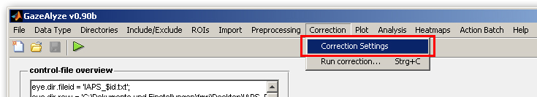

A new window will appear divided into 3 windows.

1. Choose the used method for correction. Median of scanpath will do fine most of the time.

2. If your fixation cross does is not centered into the middle of the screen you can shift it by entering values here. If your fixation cross is centered in the middle of the screen leave everything as it is.

3. If you have imported a separate fixation period just hit the first radio button like shown in the screenshot. The values will be listed automatically.

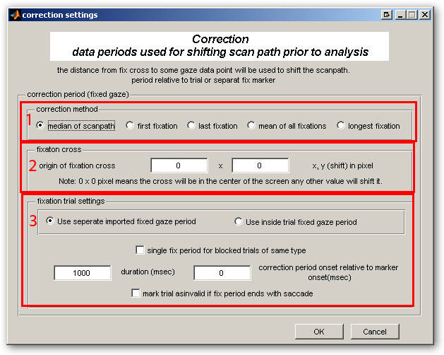

Now you just have to select Correction-> Run correction and the correction files will be generated and stored in a folded called corr.

